ASSINGMENT No.3(INTRODUCTION TO DATABASE)
Question 1:Create Database
Answer:
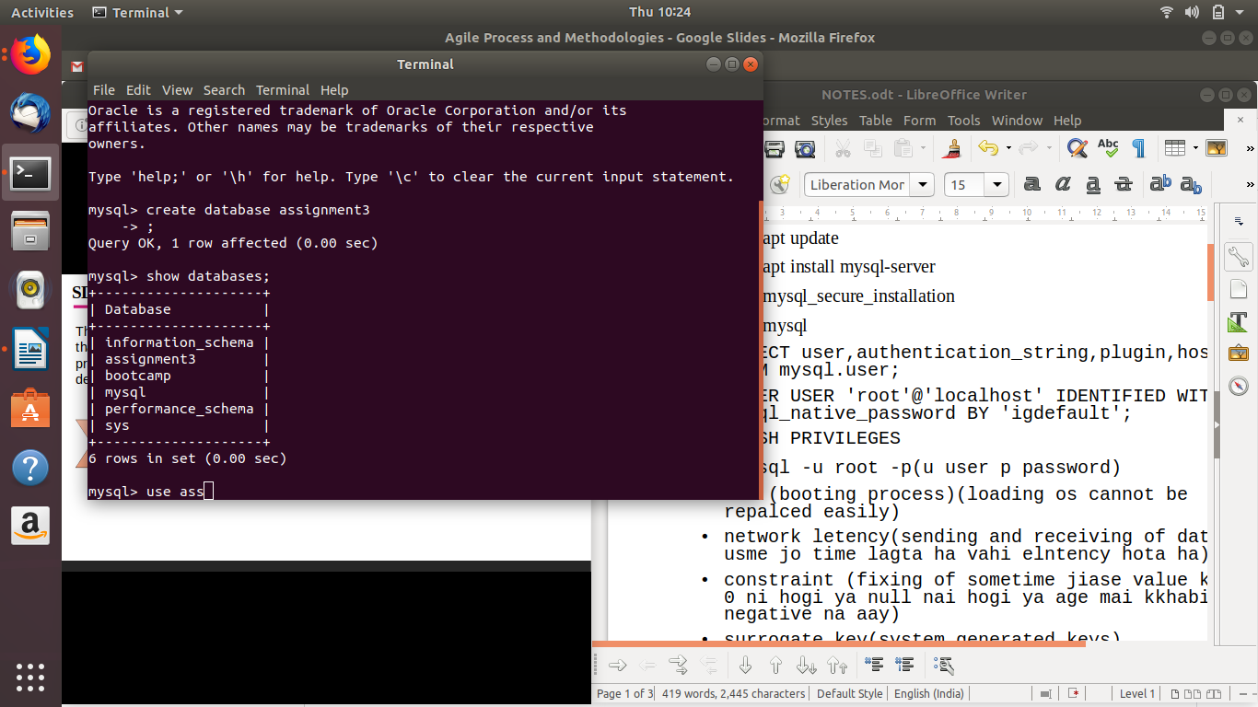
Question 2:Design Schema
Answer:
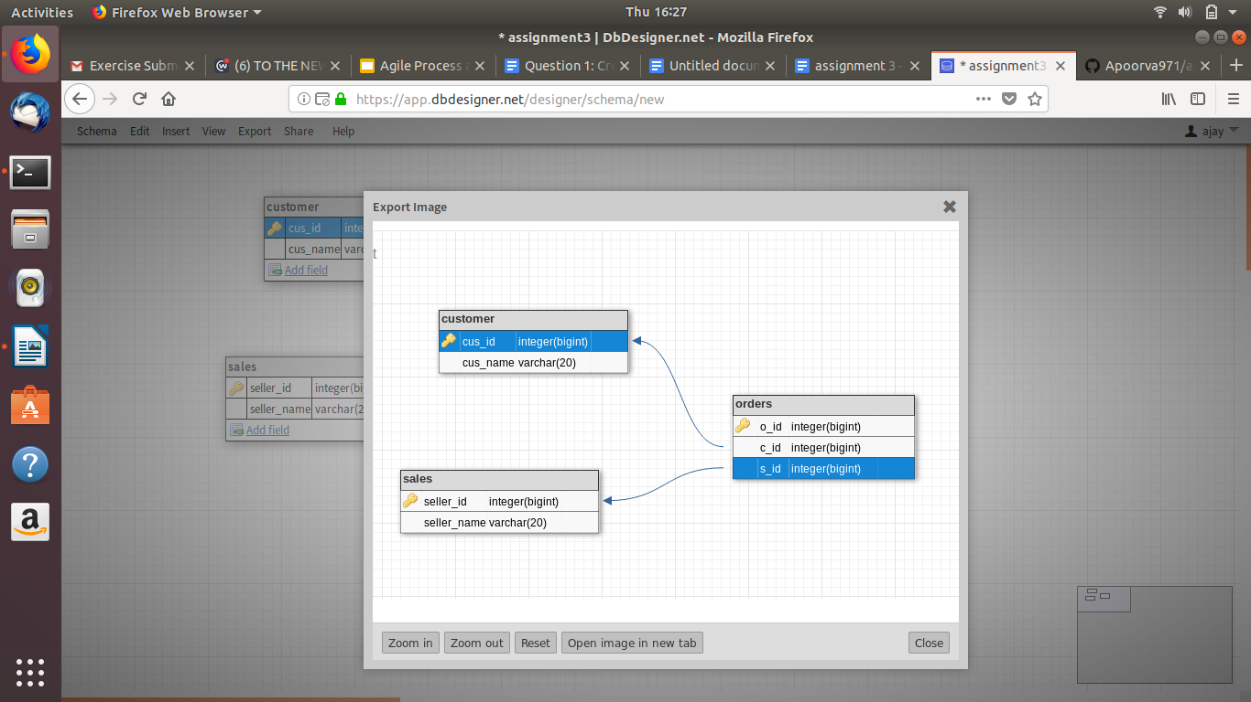
Question 3:Create tables
Answer:
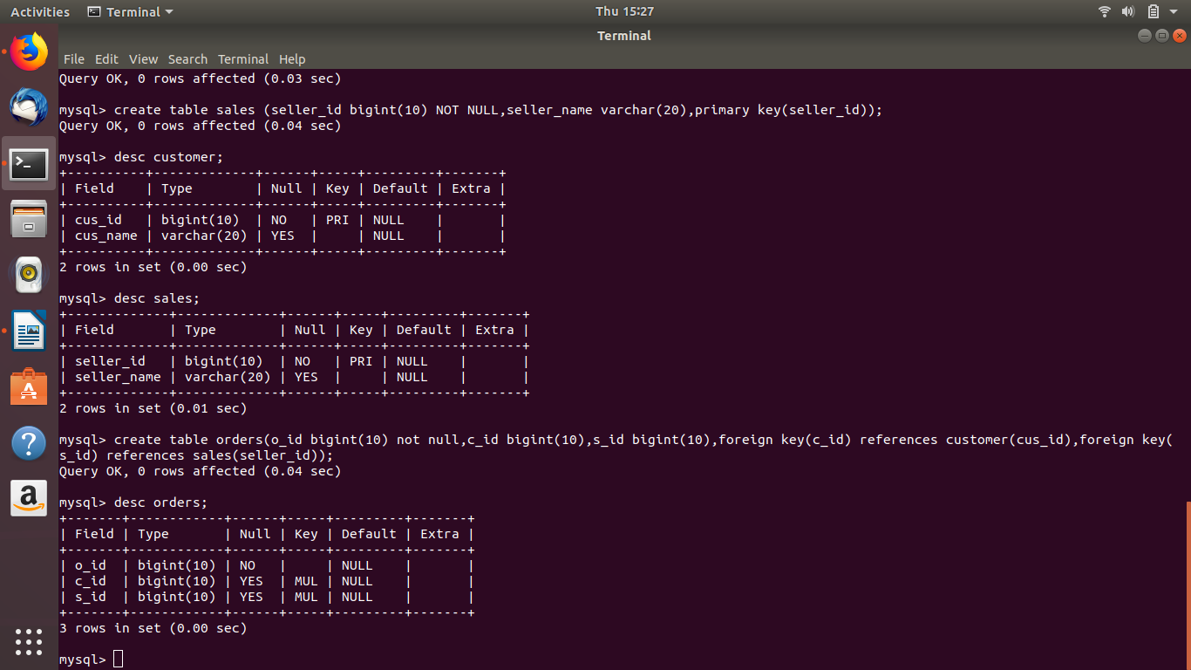
Question 4:Insert sample data
Answer:
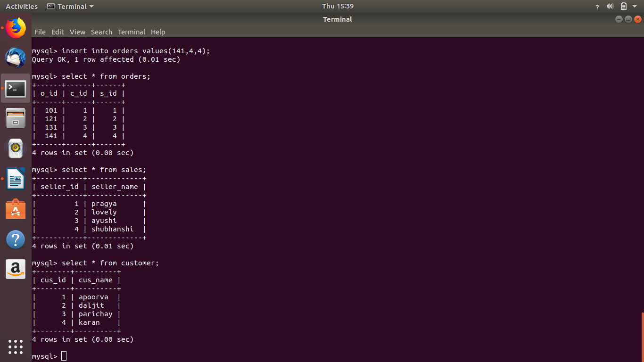

Question 5:Find the sales person have multiple orders.
Answer:

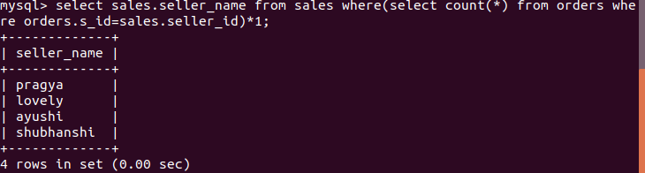
Question 6:Find the all sales person details along with order details
Answer:
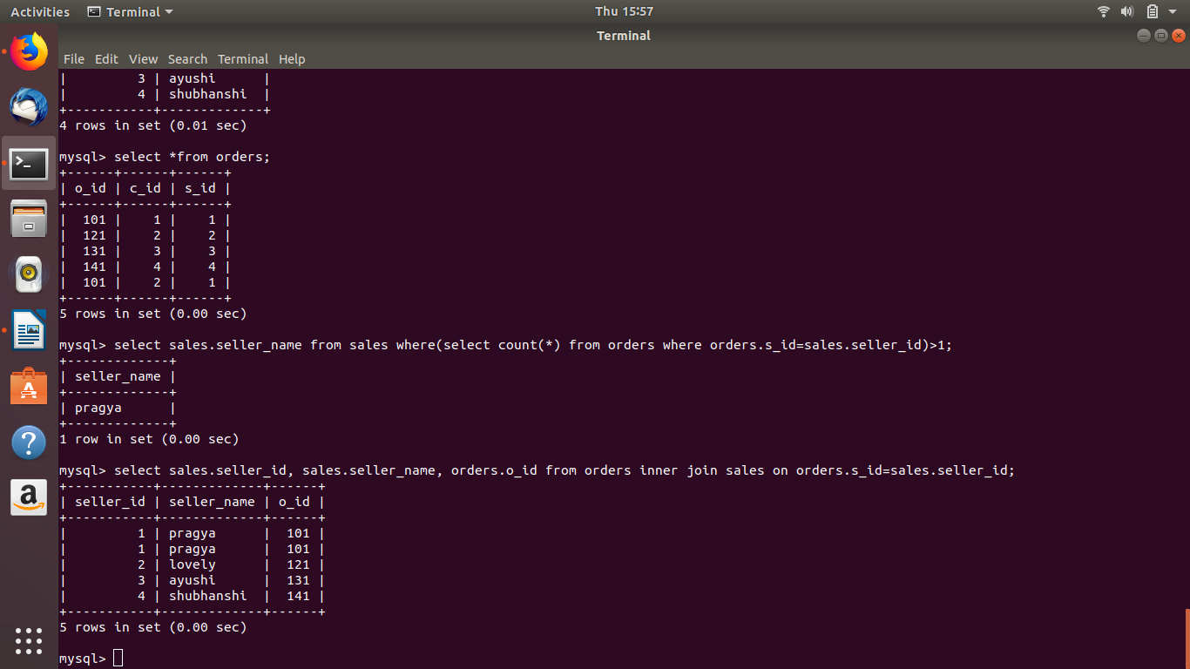
Question 7:Create index
Answer:
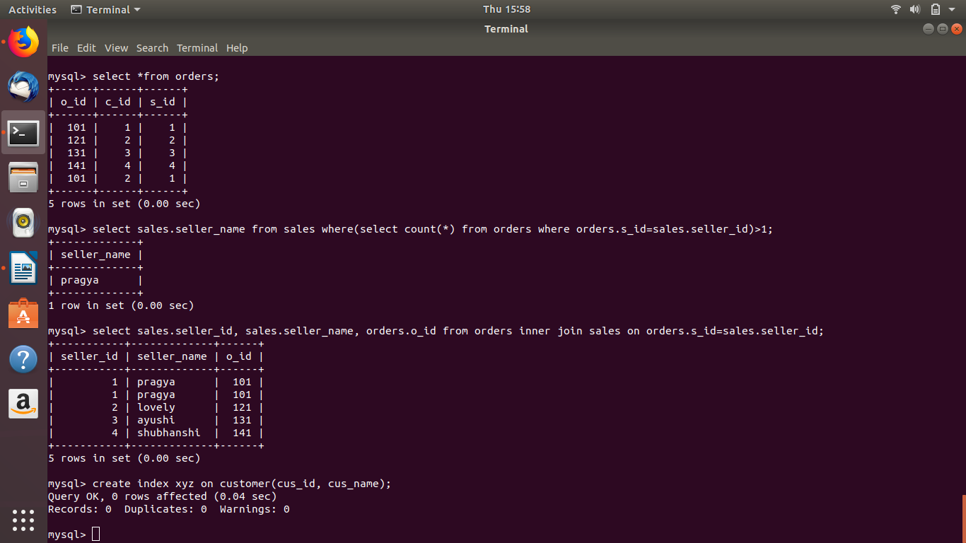
Question 8:How to show index on a table
Answer:
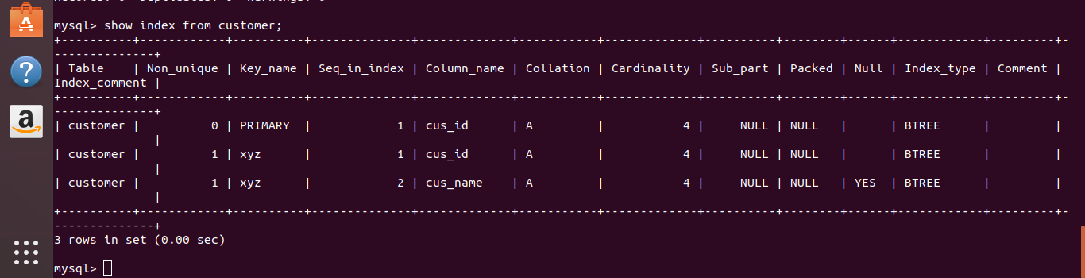
Question 9:Find the order number, sale person name, along with the customer to whom that order belongs to
Answer:
